- where this feels accurate
- where it misses your experience
- edge cases we’re not naming yet
Page 1
Given that you are trying to help the respondent to understand their propensity for satisfaction and/or understanding their level risk of adverse experience of owning an EV (friction), I’m not sure why you would need vehicle information, with the exception of making them feel good about their interest in, or ownership of, and EV, and thereby increasing likelihood of completing the survey.
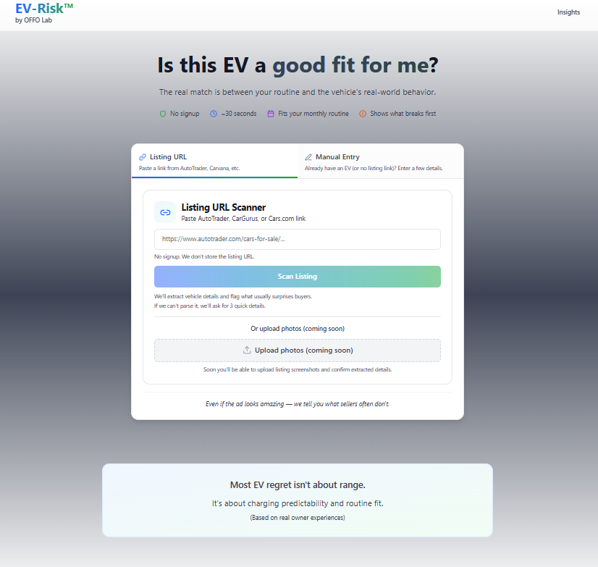

Page 2
Same comments as above, but if there is a rationale for including vehicle detail, suggest…
- you have a model dropdown by make and year. That data shouldn’t be too difficult to acquire.
- What are you intending to glean under “Mileage” and then having “Select Range” in the box? If truly range, then suggest range appropriate numbers for an EV, so, “125 to 199 miles”, :200 to 250 miles”, etc…”No”, and why do you need that information?
- No need to have upload photo” continue beyond initial page, and again, why is it necessary in the first place?
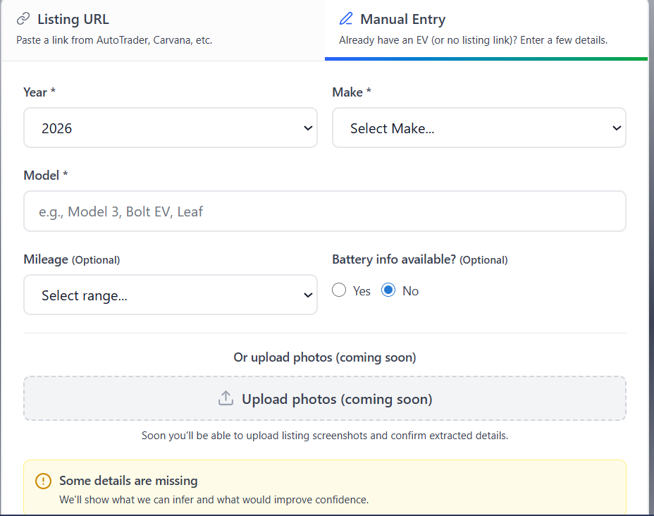

Page 3 (Quick Check Questions)
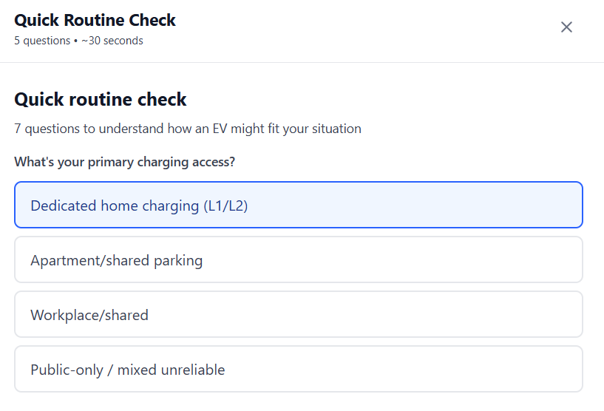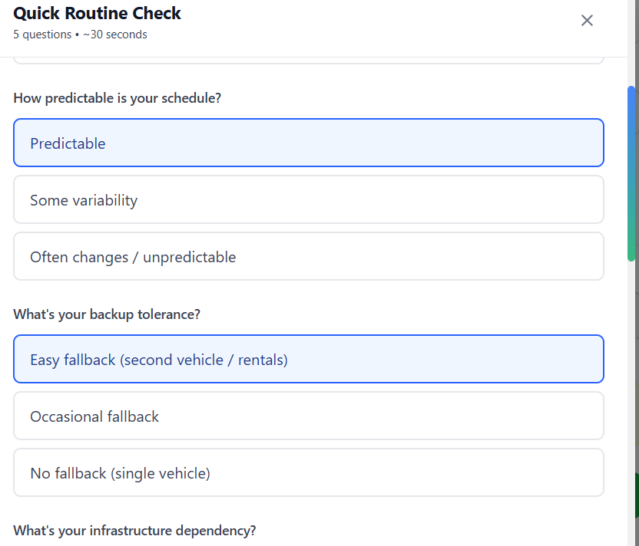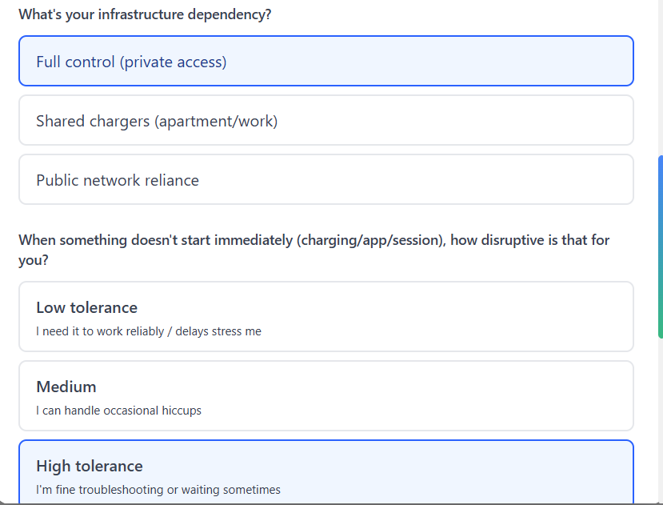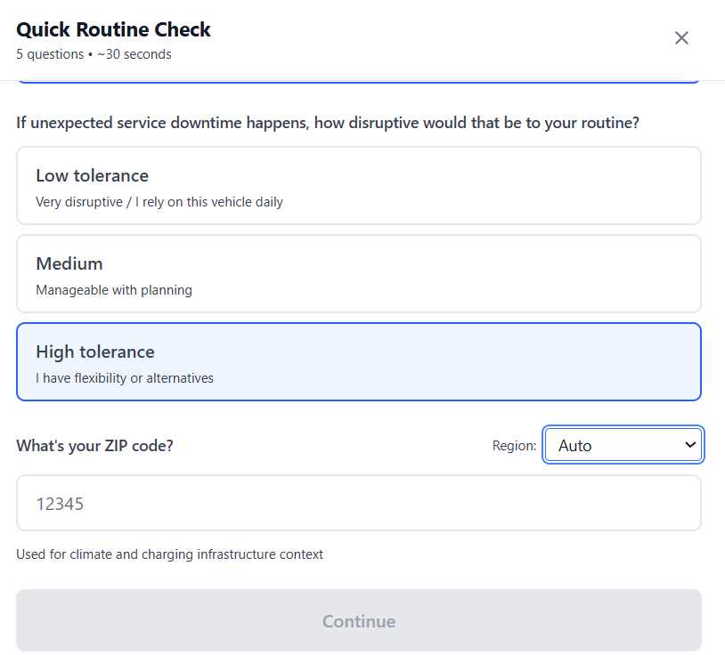

Summary Page
- First, you say five questions and seven questions to two separate spots.
- The “In situations like yours” does not reflect responses to the questions…
  - I have access to L1/L2 chargers, minimal infrastructure dependency, high tolerance to disruptions, predictable schedule (more comment on this below), easy fallback to 2nd vehicle, and high tolerance to downtime.
    - Predictable Schedule…may want to clarify what this means, such as “daily commute during weekdays” as an added note.
- My situation…After reading this a few times I think I see what you’re trying to get at.
Given my responses, you could be clearer…
  - “Occasional hiccups…” you’re referring here to public charger hiccups, such as charging app issues, charging issues, and having to retry public charging. But I had indicated that I have an L1/L2 charger, that my infrastructure dependency is low, etc., so this, at least to me, is not a meaningful assessment.
  - Unpredictable Schedules…” this goes to my schedule response, but I viewed this as “I’m retired and I can predict my schedule as I want” rather than what I think was your intent of “I commute on weekdays to an office from home”. Again, you may want to rephrase this.

I’m not going into the full report to comment, but I just scanned it and see that it appears you plan on gathering additional data points, which is good. But, note that some of the conclusions simply do not match data point responses. And such things, as an example, as saying that I live in a favorable climate (based on my zip), strikes me as inaccurate, especially given I live in northeastern US with cold snowy winters and hot summers. To me losing range in the cold does not strike me as a favorable climate for an EV. It’s ok and I tolerate it.

Thinking back now to the questions, I suggest you include tolarances to the nature of EV’s themselves. They’ve been aptly described as cell phones with big batteries on wheels. Their software, and more specifically, their software maturity, or lack thereof, call result in major hesitancy, as well as vehicle controllers (ICCU, BCM, etc.). Even the Hyundai Ionic 5, a model that has been around for 5 years now (I believe), has major issues. Also look up Polestar3, etc.). This is a major point of hesitancy.
MyI 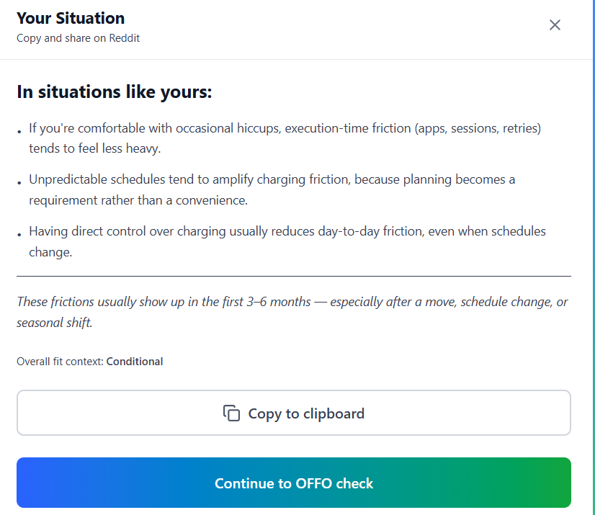
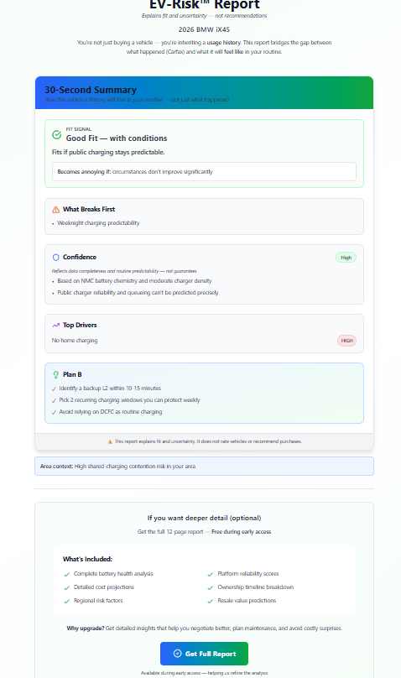

https://offolab.com/report?data=%7B%22model%22%3A%22BMW+iX45%22%2C%22year%22%3A2026%2C%22currentMileage%22%3A45000%2C%22homeCharging%22%3Atrue%2C%22dailyMiles%22%3A100%2C%22zipCode%22%3A%2219075%22%2C%22riskTolerance%22%3A%22aggressive%22%2C%22source%22%3A%22sanity-check%22%7D

